Dignity of the human person and homelessness
What is Catholic Social Teaching?

Catholic Social Teaching (CST) has been described as “The Catholic Church’s best kept secret”.​ CST is a set of writings rooted in scripture on ethical values put forward by the Church. It is not just a body of teaching but a call to action. ​It is our moral compass for practical action. ​

CST offers a way to articulate our thoughts about what matters and the reasons for our actions in response to injustice.

Watch this video of Bishop John Arnold explaining why CST is important for us within the Diocese of Salford – CST and Caritas

You can also watch a brilliant explainer video here from Busted Halo – Catholic Social Teaching in Two Minutes
The video covers all the themes of CST (they are named and listed differently across organisations; however they all cover the same values), but this guide will have as its focus the theme that underpins all others – human dignity.

What is the dignity of the human person?

The foundation of Catholic Social Teaching is the principle of human dignity. Rooted in the example of Jesus in the Gospels, it teaches us that no matter what a person’s characteristics (whether it be their age, gender, social class etc) they should have their dignity respected – as every human is made in the image and likeness of God.

What does this have to do with homelessness?

A lack of stable, good-quality housing makes it incredibly difficult to live a life compatible with dignity. Striving for everyone to have a safe and adequate home is part of ensuring that our neighbour’s human dignity is valued and that we are working for the common good.
CST and the theme of human dignity teaches us that we are not benefactors of those experiencing homelessness, but are partners with them – accompanying and doing with, not to – as their human dignity is equal to our own.

“Just as the commandment “Thou shalt not kill” sets a clear limit in order to safeguard the value of human life, today we also have to say “thou shalt not” to an economy of exclusion and inequality. Such an economy kills. How can it be that it is not a news item when an elderly homeless person dies of exposure, but it is news when the stock market loses two points? This is a case of exclusion. Can we continue to stand by when food is thrown away while people are starving? This is a case of inequality. Today everything comes under the laws of competition and the survival of the fittest, where the powerful feed upon the powerless. As a consequence, masses of people find themselves excluded and marginalized: without work, without possibilities, without any means of escape.”
Evangelii Gaudium (“The Joy of the Gospel”), Pope Francis, 2013

Homelessness and our Diocese

Homelessness is a complex issue; interlinked with poverty and other factors. There are different forms of homelessness which exist across our Diocese:
- Statutory homelessness: this is when Local Authorities have a duty to secure a home for a person.
- Rough sleeping: this is when someone could be seen sleeping on the streets and is considered the most visible form of homelessness.
- Hidden homelessness: this is when someone does not have a home, but they are not captured by official statistics (such as people who are ‘sofa surfing’, sleeping in their cars, etc)
- In temporary accommodation: this is when someone is staying in a hostel, bed and breakfast, or similar.
- And those at risk of homelessness: this is when someone is at risk of losing their home (for example this may be due to potential eviction or poverty and difficulties maintaining rent).
Crisis provided a more detailed overview of each here - Types of homelessness | Crisis UK | Together we will end homelessness
The latest available data shows that within the Diocese of Salford, between January and March 2023:
- 4,978 households were in temporary accommodation
- 6,427 children were in temporary accommodation
- 7,231 people approached their councils because they are homeless or threatened with homelessness

How Caritas Salford help

At Caritas Salford we support people who are experiencing homelessness through a number of our frontline services.
- Cornerstone Daycentre: our centre for people who are experiencing homelessness. We provide housing advice; including referrals to emergency accommodation, pre-tenancy, resettlement and tenancy sustainment support. We also have showers, a clothing store, and offer a low cost breakfast and lunch.
- Morning Star Hostel: safe, high quality supported accommodation for 20 single homeless men, who share a lounge, newly refurbished self-catering kitchen and dining room and laundry facilities. Each resident has a support worker who will work with them to address the issues which led to them becoming homeless and to help ensure that they can move on and successfully resettle in the community.
- Red Door (Bury): we provide much-needed support for people to find temporary and permanent accommodation, and help people to access benefits and other services. We also provide a friendly drop-in centre where clients can have a shower, do their laundry, and socialise with other people.
- Lalley Centre: is a vibrant Community Centre, food pantry and community allotment based in North Manchester. They support people with practical needs and in areas such as food support, wellbeing and housing.
- Young Parent accommodation: this service provides safe, comfortable accommodation and support for vulnerable young parents and their children. The services are based in Bolton and Blackburn and routinely accommodates up to seventeen young parents and their infant children at any one time.
Also, through our Advocacy work, we try to be a voice for those who cannot speak for themselves, whilst also empowering people, and advocating for social justice.
You can read more about what we do on our website – Caritas Salford: how we help

How can you and your parish help?

There are a variety of ways that you and your parish can support those experiencing homelessness. From developing social action projects of your own, to volunteering with Caritas services and supporting our fundraising, there is something that everyone can do. Firstly, it is important to assess how best you can help by seeing what issues impact your community.
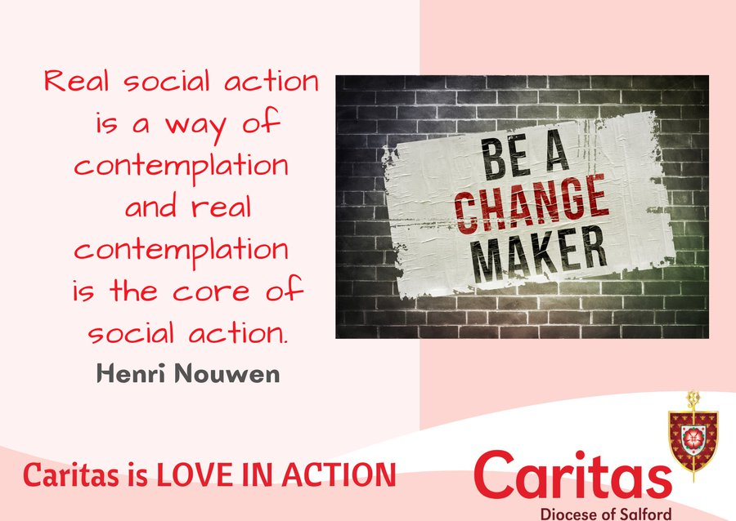

See and discern

When considering social action, we use the See, Judge, Act methodology. This was developed by Cardinal Joseph Cardijn, founder of the Young Christian Workers movement, and has been used by Pope France (the encyclical Laudato Si’ follows this method). It allows us to step back and reflect, before leaping into action.It is important to avoid making assumptions about the issues your community may face. To ensure this, individuals and communities must be allowed to participate in the responses and decisions that affect them – this is consistent with the Catholic Social Teaching principle of subsidiarity (meaning that decisions are made by the people closest and most affected by the issues and concerns of the community). Through accompanying and engaging in active listening with people experiencing homelessness, we have a much greater chance of developing the most practical and effective ways of supporting those in need.
There may be existing projects that you can take inspiration from or engage with in your local community – replicating good practice is effective and efficient. These could include actions already being organised by other Christian churches or faith groups. Take time to discern where a Catholic presence is most needed. If there are similar resources, groups, or social action projects, could you support them instead of setting up a new project?
The Diocesan Hope in the Future team have created a resource to help you to listen and discern what the needs are in your parish and wider community – Hope in the Future Stage 5 resource

Act

There are many different ways in which your parish can respond to support people experiencing homelessness. The forms of action detailed below are a snapshot of what could be done.

Pray

As Catholics, we are called to recognise the face of Jesus in the faces of all people, in particular those who are marginalised. Prayer is more important now than ever as we seek to reach out to those in need. Jesus identified himself with those experiencing poverty, illness, and hunger.
- You could organise a liturgy or prayer service with those experiencing homelessness at this time and for the people, groups and organisations who seek to help.
- Consider including in the Prayers of the Faithful at weekday and Sunday Masses intentions for those in public office, and for those experiencing homelessness.

Social Action

Our parish communities are rich with experience, knowledge, energy, and enthusiasm. Although each parish and local community will have different needs, here are some of the potential options for what you could do to move from prayer to action.
Warm Hubs
Warm Hubs (also known as Warm Spaces, Public Living Rooms, and Warm Banks) are safe, welcoming, free spaces for anyone in your community to get warm. These developed quickly during the winter of 2022 in response to the energy cost crisis. But many have since developed into welcoming community spaces for anytime of the year.
But with winter always around the corner, Warm Hubs will continue to be most needed when the temperature drops and heating the home becomes less affordable. Our parish buildings can often be best placed to provide a space for people to keep warm, meet others, and relax.You can read our guide to creating a Warm Hub here – Parish Resources
Community meals
Food insecurity is another reality for those experiencing homelessness. Especially at Christmas time when many other services are reduced or closed for the festive period. In 2022, a group in Bury provided Christmas meals for 700 people who otherwise would have struggled to afford it.
You can read our guide to facilitating a community meal here – Parish Resources
NACCOM
The “No Accommodation” network whose members operate hosting schemes in which people can offer a free private room within their home to someone experiencing homelessness and are in the asylum and immigration system.
You can find out more here - Host a refugee in your home | Offer a room | No Accommodation Network (naccom.org.uk)
Signpost
It is important to also know where to signpost people who may present to your parish experiencing homelessness. The Local Authority homelessness services should be signposted too initially.
Homeless households - Lancashire County Council
Help if you are at risk of losing your home | Help and advice services | Manchester City Council
Also, across the Diocese there are a number of social action projects that are run and supported by parishes which you can find on our social action map here - Social Action Map

Fundraise

The support we offer to people experiencing homelessness through our Caritas Salford services would not be possible without the time and generosity of those who fundraise for us.
There are many ways you can fundraise; from organising a sponsored walk, hosting a coffee and cake morning, to donating in someone’s memory. You can read about the different ways to donate here - Donate - Caritas Diocese of Salford
Here are two fundraising activities that directly support those experiencing homelessness:
Big Sleep Out
A Big Sleep Out is choosing not to sleep in the comfort of your own bed for one night only and asking people to sponsor you.
You can arrange one on your own, with friends, family or colleagues and at a time that works for you. It can take place at home, at work or at a community centre.
A Big Sleep Out isn’t intended to show what it’s like to seep rough, but instead helps us all to stop, reflect and think about what many young people and adults experiencing homelessness are facing every day.
Read more here – Big Sleep Out
Sponsor a room
Sponsoring a room at our Morning Star Hostel or Young Parent Accommodation would enable homeless people or young families to move off the streets or insecure accommodation and have a comfortable room with brand new bedding, towels, curtains, carpet, furniture, their own fridge and kettle and pictures on the wall to make it homely. £1,500 would enable us to do this upgrade.
In return we include your name on a list of sponsors in our entrance hall and we would be delighted to arrange for you to come and visit the project to see for yourself the difference your funding will make and/or we can arrange to come and give a talk within your parish.
Please contact our fundraising team ask any questions or talk through any ideas you have - fundraising@caritassalford.org.uk

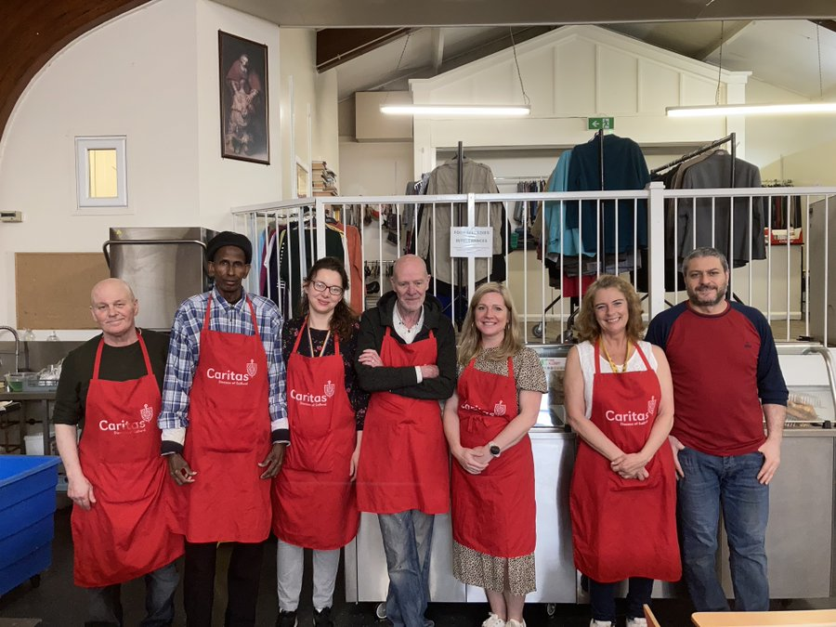
Volunteer

We have a variety of volunteer opportunities at Caritas Salford which directly help those experiencing homelessness. Our services could not offer the amazing support that they do without the commitment of our volunteers, and we are always looking for more people to get involved!
- Cornerstone Day Centre
Cornerstone works to ensure that people in Manchester have the support they need to prevent them from becoming homeless, that people who do become homeless are helped to secure safe accommodation with the support they need to make a new home and that no one has to sleep rough. As a volunteer at Cornerstone you can support us by doing practical tasks such as preparing and serving food, washing up, sorting donations and making up food parcels, cleaning, organising the showers and staffing our community shop.
You can read more about volunteering at Cornerstone, and apply, here - Cornerstone Service Volunteer (Manchester) | Caritas Salford Volunteering (goassemble.com)
- Red Door service
In Bury, our Red Door is a drop-in centre for those experiencing homelessness and other issues. By volunteering you can support the team by preparing and serving toast and hot beverages, cleaning, chatting with and listening to people who use our services, and organising food store and cloth donations.
You can read more about the role, and how to apply, here - Red Door Service Volunteer (Bury) | Caritas Salford Volunteering (goassemble.com)
- Community pantry
Help support our community pantry in North Manchester which provides discounted food to those that need it.
You can read more here about what to expect and how to apply - Food Provision Volunteer (North Manchester) | Caritas Salford Volunteering (goassemble.com)
- Van driver
As a volunteer van driver you would be helping to support the vital work of Caritas Salford by providing valuable assistance in the transportation of donations and other materials.
You can read more here about the role, and how to apply - Volunteer Van Driver (Manchester) | Caritas Salford Volunteering (goassemble.com)
If you have any questions about volunteering, please contact us on volunteering@caritassalford.org.uk.
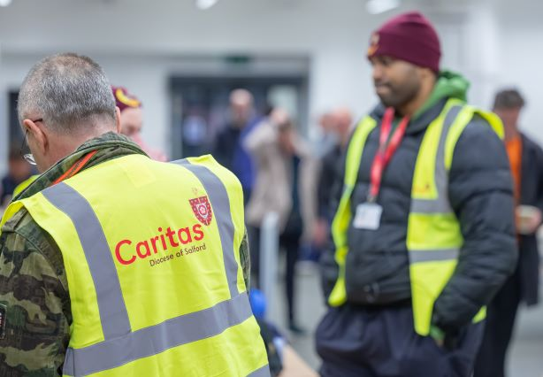

Campaign

The causes of homelessness are often deep-rooted and systemic. One way in which you can try to address the root causes is through campaigning. By putting pressure on people in power, we can make change possible.
- Writing to your MP
Writing a letter to your local MP is an effective way means of raising awareness about homelessness in your area; as local pressure can lead to national change.
This could be an email, or a handwritten letter, and should include your name and address, why you are worried about homelessness, and what you would like them to do (this could by asking a Parliamentary Question, requesting a debate, or writing to the relevant minister e.g. Department for Levelling Up, Housing, and Communities).
Find out who your local MP is using www.theyworkforyou.com
If you want to find out more about how you can help our campaigns, and advocacy work take a look at our resources – Campaigning and Advocacy Resources
Read more about our policy and advocacy aims here: Policy and Advocacy
You can also contact our Advocacy, Policy, and Research Coordinator – Mimi Wilsher at M.Wilsher@caritassalford.org.uk

Accessibility

Accessibility is about ensuring that everyone can take part and contribute in the way, and to the extent, which suits them best. It is not a matter of convenience but a basic requirement to honour human dignity. No person should be restricted in their participation because of an unmet physical, mental or emotional health, learning or sensory need. If you are considering developing a project or becoming involved in social action, it is important that you consider potential (or known) accessibility needs from the planning stage to reduce the need for adjustments. Often, the smallest change can make a world of difference to a person.
Dr. Minna Moffatt-Feldman (Caritas Accessibility Coordinator) is available for advice regarding accessibility and overcoming barriers (m.moffatt-feldman@caritassalford.org.uk).

Safeguarding

When planning and conducting any of the ideas included in this guide, it is important that you always consider the safeguarding implications. The CST concept of dignity of the human person confirms a duty to protect people from harm, one means of which is robust safeguarding.
The Diocesan Safeguarding Department have designed guidance and resources to help you manage this. The Catholic Safeguarding Standards Agency have also designed important resources and templates for projects to recruit safely, respond to allegations and concerns, and develop codes of conduct.
If in doubt, contact the Diocesan Safeguarding Department to discuss things further.

Get in touch

If you have any questions or want to let us know what you do in your parish, please do get in touch. Contact our Parish, Communities, and Volunteer Engagement Officer, Matthew Yates – m.yates@caritassalford.org.uk
To subscribe to our monthly newsletter please click here, or email comms@caritassalford.org.uk

“Jesus came to the world homeless, and made himself poor. Then, the church wishes to embrace all and to say that it is a right to have a roof over your head. In popular movements they work according to the three Spanish T’s: trabajo (work), techo (roof), and tierra (land). The church teaches that every person has a right to all three.”
Pope Francis (2015) in an interview with “Straatnieuws” – a Dutch newspaper created by those experiencing homelessness

