Community Sponsorship and your parish

What is Community Sponsorship?

Community Sponsorship is a scheme that enables a committed local group to safely resettle, welcome, and support a family of refugees directly in their local community.
The scheme aims to enable a refugee family to gain independence and pursue their aspiration in the UK. It is a unique opportunity for parishioners to live their faith through action and respond to Pope Francis’ call in September 2015 for ‘every parish, every religious community, every monastery, every sanctuary of Europe, [to] take in one family’.
Community Sponsorship is a Home Office approved scheme, which Caritas Salford are a lead sponsor of. We support local community groups to deliver safe and legal routes to resettlement. At Caritas Salford we have experience of doing this over several years and we will guide you through the scheme so that it is achieved safely and effectively.
Throughout the process you will have the support of the Caritas Salford Community Sponsorship Development Coordinator.

Who is involved?

The scheme can be divided in the following phases:
Year 0
Year 2
Year 1

Application
Year 0: Group Formation & Preparing Application
3

Your Group would start by preparing the resettlement plan (application) which will include the following Home Office requirements:
- Fundraise £9,000
- Finding access to a new home that is secured for two years from the date of arrival of the family and preparing it to welcome them.
- How you will support the family settle in the community and gain access to services like local GP, bank account, interpreters, apply for eligible benefits.
- Engage with and arrange local school places for children and 8 hours English classes for adults.

Trainings and administrative requirements

Caritas Salford’s is focused on ensuring the safety and safeguarding of all people, and that they are treated with respect throughout the experience. Therefore, there are some essential training, safeguarding checks and expected behaviours that people involved need to understand in advance. You will need to:
- Register as Caritas Salford volunteer (which includes reference checks and a Disclosure and Barring Service (DBS) check
- Complete “Introduction to Community Sponsorship” training
- Read and understand the Volunteer Handbook
- Undertaken online training: Safeguarding adults and children, Health and Safety, Human Trafficking.
- Trauma and culture training
- How to use Lamplight (case management system)
Year 1 and 2: After Arrival

Testimonials from families and volunteers
“On the first day of our arrival, I was afraid, I was very scared. I arrived at the airport in Manchester and we were welcome by the group. It was a difficult feeling, I started crying but they were very welcoming. The group prepared a family atmosphere in the house. They liked the children. In the way they have welcomed us, they made us feel that exile and what we were afraid of was reduced. As if they were friends.”
“We came here for the future of our children, for them to study here, to become someone, to help this country. That’s my dream for my children […] this country has now become their country.”
“People show humanity between friends, neighbours, in public gardens. We thank God for having brought us here and it’s better. Life was harder before, here there is safety, humanity, support.”
“People became friend through this process, in church and in the parish when they would have never spent time before.”
“Several of us have got to know one another better through the scheme and made friends.”
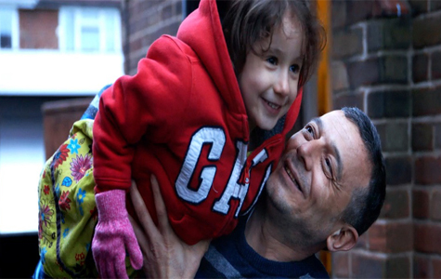

Read more
Community Sponsorship and Caritas Salford
Community Sponsorship government guidance for prospective sponsors
How Community Sponsorship can change lives – Reset UK
Love the Stranger – A Catholic Response to Refugees and Migrants

Get in touch
If you are interested in your parish becoming involved in the Community Sponsorship Scheme, please reach out to us via communitysponsorship@caritassalford.org.uk

“The Catholic community in England and Wales is living this out every day: our charities are caring for people in the asylum system, our parishes are welcoming families through community sponsorship, our aid agencies are providing life-saving assistance to displaced people across the world, and countless volunteers are bearing witness to Christ’s love in settings from beachfronts to detention centres.”

Love the Stranger – A Catholic Response to Refugees and Migrants

“Refugees can experience, along with difficulties, new, welcoming relationships which enable them to enrich their new countries with their professional skills, their social and cultural heritage, and not infrequently, their witness of faith”
Pope Francis, Message for the World Day of Migrants and Refugees

