_____________________________ is taking part in the Caritas Big Sleep Out on
_______________[date] to raise money for local people experiencing or at risk of homelessness in Greater Manchester and Lancashire. Please use our JustGiving page justgiving.com/campaign/bso2024 and donate there if you are able to which will save the charity administration and processing costs.

Thank you so much for your support!
*By ticking to Gift Aid I confirm that I am a UK Taxpayer and I agree to Caritas Diocese of Salford claiming tax on this donation. I confirm that I am paying an amount of Income Tax and/or Capital Gains Tax to cover the amount Caritas and any other charities will reclaim for the Tax Year. Caritas will claim 25 pence of tax for every £1 that has been given.
SPONSORSHIP FORM
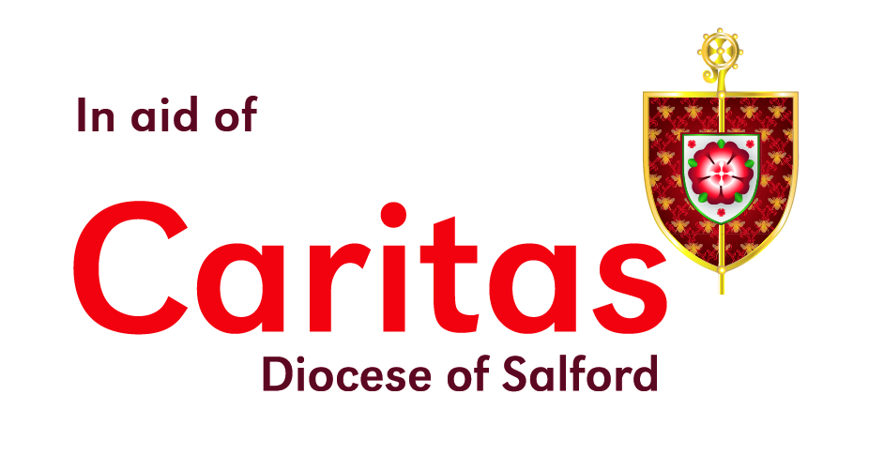
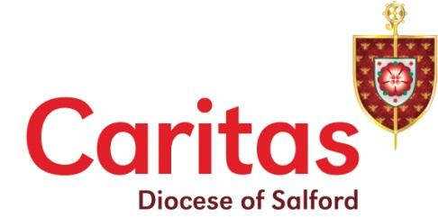
Caritas Diocese of Salford’s vision is for a society where there is justice and equality; where the voices of those experiencing poverty, disadvantage and/or discrimination are heard and acted upon, so that all people can live in peace and dignity. We provide a practical response to those in crisis whilst people rebuild their lives for the long term.

Full Name | Home Address | Postcode | Email  (to receive Caritas updates only) | Gift Aid* | £ Sponsored | Date Paid
Visit caritassalford.org.uk/pay-in-your-money/ when you are ready to pay in all of the money raised or contact Kirstie fundraising@caritassalford.org.uk or 0161 817 2281 in case of query. Thank you!
Registered Charity No. 1125808

